Minnesota State Park Guide

# Moose Lake State Park

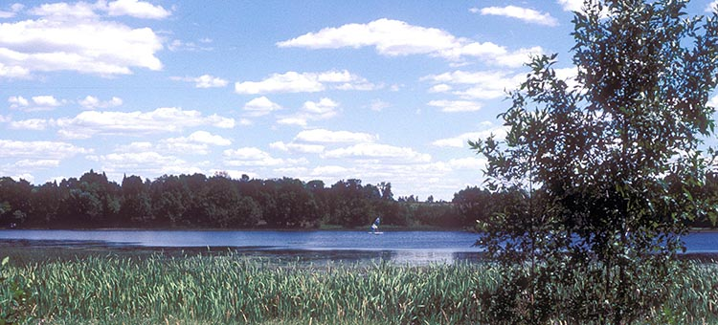

## Highlights

* Close Access To Recreation
* Quiet Lake Offers Great Canoeing
* Lots Of Family Activity Choices
* Fishing/Fishing Pier
* Wildflowers & Wildlife Viewing

## Geology

The park lies in an area covered by glacial till and outwash deposits from the last glacier. Large ice blocks which melted after the glacier retreated created both Moosehead and Echo Lakes.

## History

Beginning in 1962, local residents began working for the establishment of a state park in order to increase the number of camping sites in the area. The park became a reality in 1971 and by August of 1977, a picnic area was completed on the north shore of Echo Lake. Over the years, additional campsites, picnic areas, hiking trails and a swimming beach have been added.

## Landscape

The park is a mix of fields, woods, woodland wildlife ponds, and fishing lakes. Wooded areas of the park contain mature aspen stands mixed with basswood, birch, and maple trees.

## Park Information

Rolling hills surrounded by fields, woods, ponds and fishing lakes make this park popular for hikers, anglers, canoeists, swimmers and campers. Quiet Echo Lake is ideal for catching bass, northerns and panfish. The Willard Munger Trail is located two miles west of the park. The trail stretches for 60 miles from Hinckley to west Duluth.

## Wildlife

The open areas of the park, along with the mature hardwood stands, combine to provide habitat for a wide variety of wildlife species including white-tailed deer, geese, ducks and a variety of songbirds. Visitors fish for northerns, walleyes, and largemouth bass in Moosehead and Echo Lakes, and for pan fish in Echo Lake.

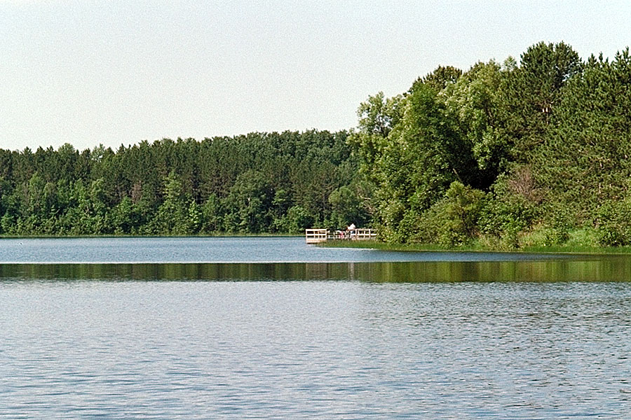

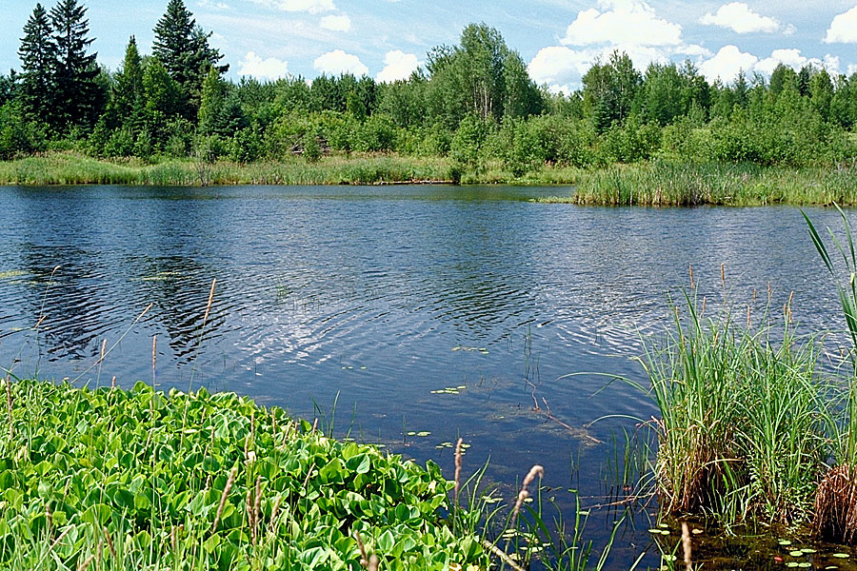

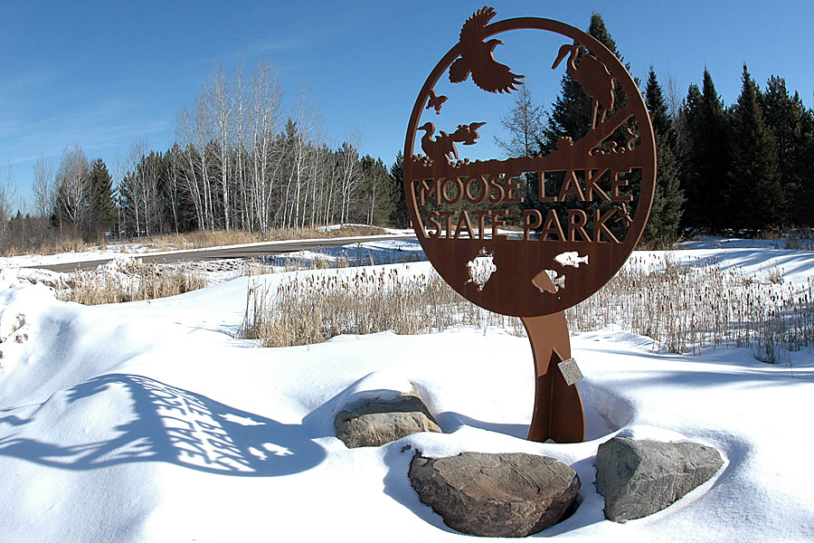

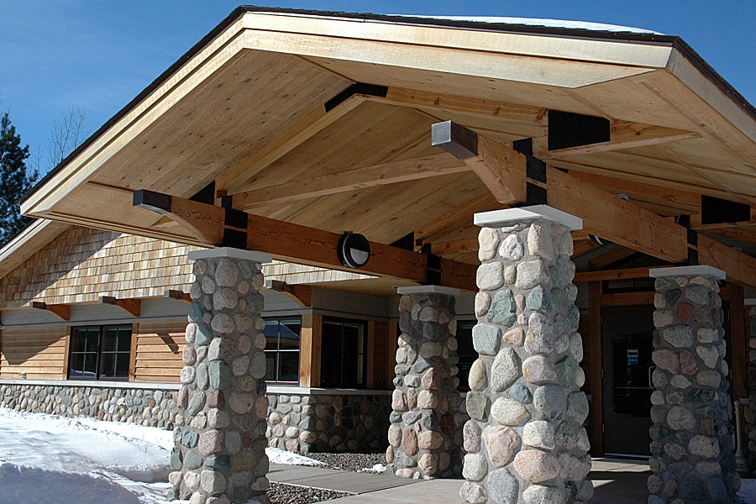

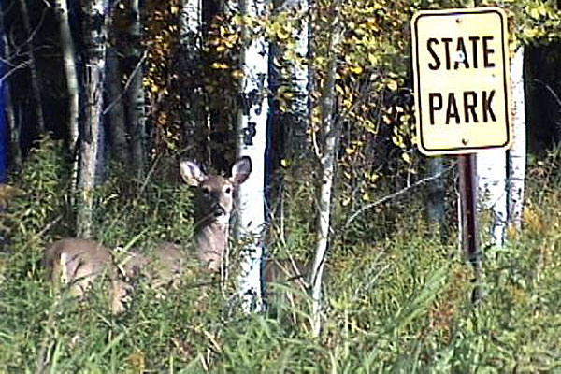

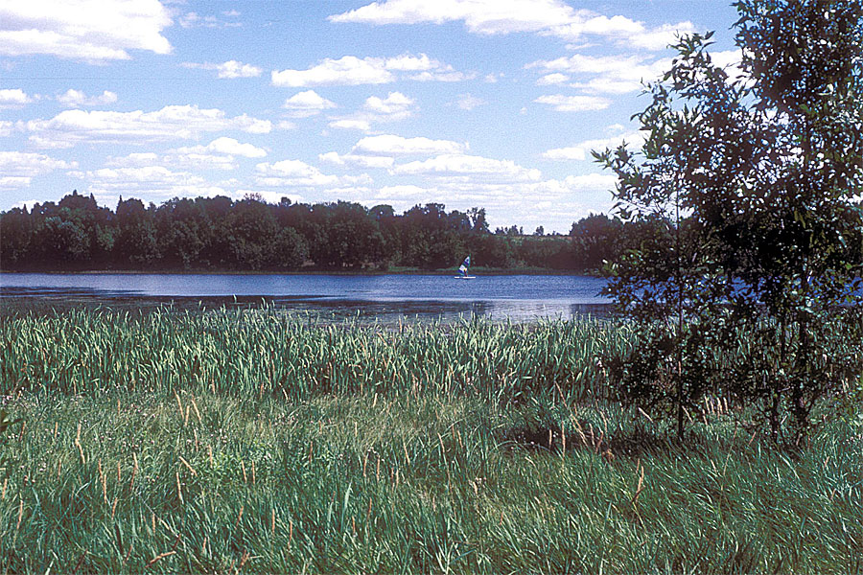

## Contact Information

### Address

4252 County Road 137  
Moose Lake, MN 55767

## Website

https://www.dnr.state.mn.us/state_parks/park.html?id=spk00239#homepage

# Upper Sioux Agency State Park

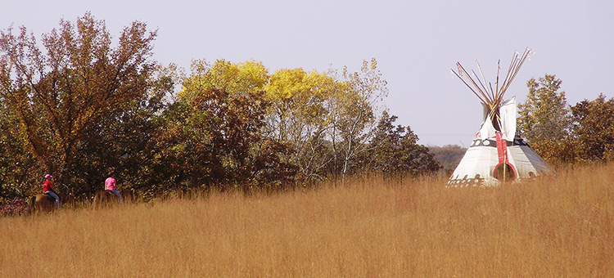

## Highlights

* Camping Including Tipi Sites
* Historic Site
* Horse Trails/Camp
* Varied Landscape/Hiking Trails
* Birdwatching

## Geology

In the summer of 1862, the Yellow Medicine Agency was destroyed during the U.S.-Dakota War. 2012 marked 150 years since the U.S.-Dakota War of 1862. Upper Sioux Agency State Park was an important location during this time. Find out how to learn more.

## History

The Treaty of Traverse Des Sioux of 1851 moved the Dakota Indians from Iowa and Minnesota to a reservation 20 miles wide along the Minnesota River Valley extending from Big Stone Lake to Fort Ridgely. The Yellow Medicine Agency was established to administer the terms of the treaty.

## Landscape

Today, Upper Sioux Agency State Park exists to preserve the historic agency site and provide recreational opportunities in the scenic Minnesota River Valley.

## Park Information

Upper Sioux Agency State Park contains the site of the Upper Sioux or Yellow Medicine Agency. The park was established in 1963 to preserve and interpret the remains of the old Agency site. The park covers 1,280 acres and offers diversity: open prairie knolls, bluffs, and cool, wooded slopes. From the vistas, visitors enjoy the trails which are ideal for horseback riding, hiking, skiing, and snowmobiling. The park also offers a huge sliding hill for winter fun.

## Wildlife

From the river's bank visitors can fish for walleyes, northerns, catfish, bullheads and carp. Watch for white pelicans and great blue herons along edges of shallow pools. Spotted sandpipers, killdeer and other shore birds frequently hunt for insects on the gravel bars and mud flats along the river. Red-tailed hawks, turkey vultures and white pelicans catch the air currents above the valley. Bald eagles winter in the Minnesota River Valley.

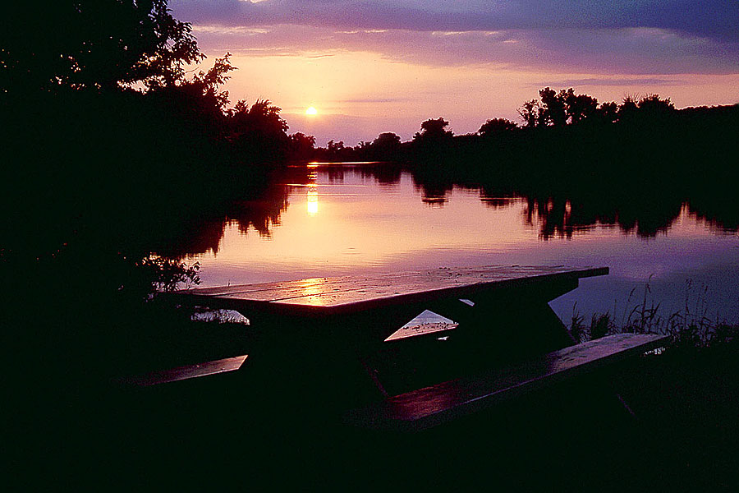

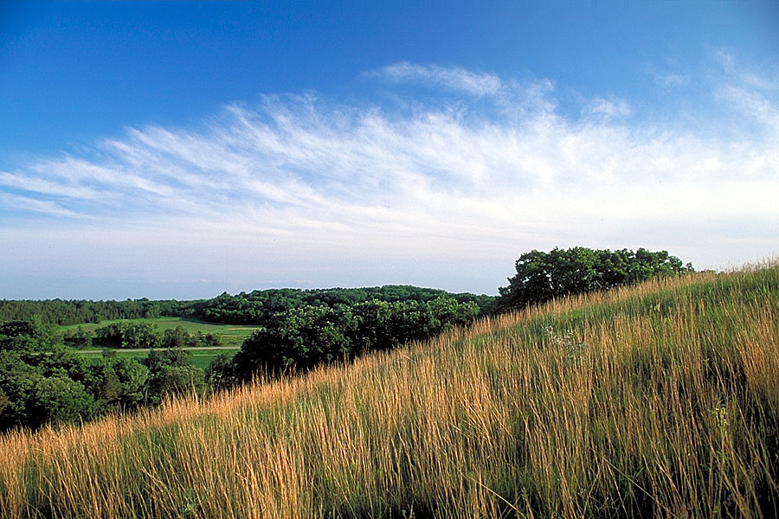

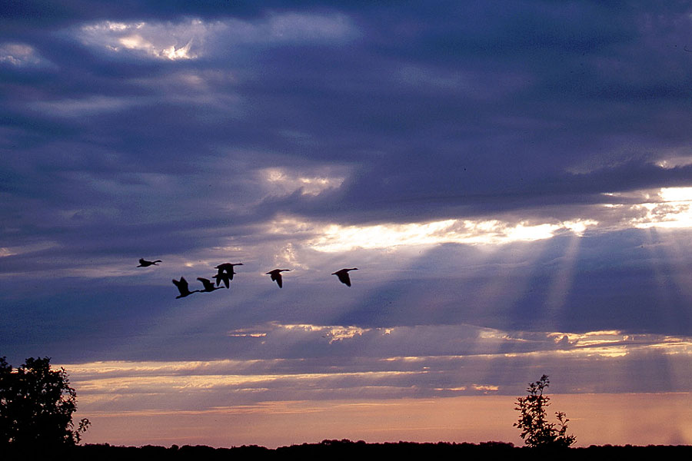

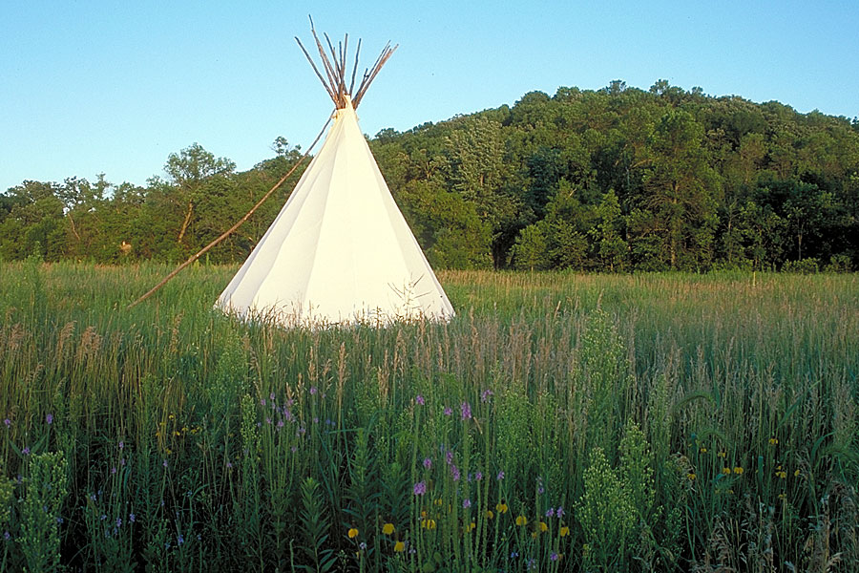



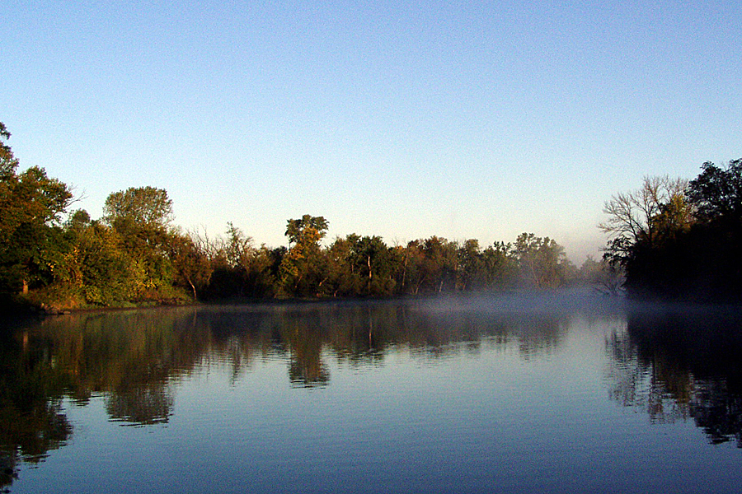

## Contact Information

### Address

5908 Highway 67  
Granite Falls, MN 56241

## Website

https://www.dnr.state.mn.us/state_parks/park.html?id=spk00277#homepage

# Fort Snelling State Park

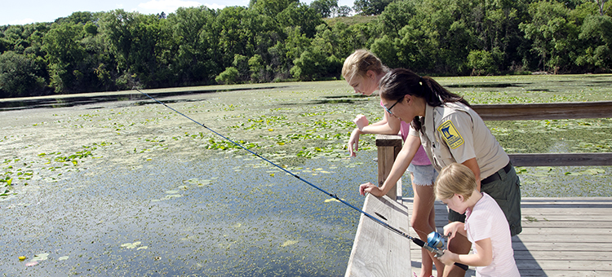

## Highlights

* Fishing
* Hiking
* Dakota Memorial
* Interpretive Exhibits
* Bike Trails/Connections
* Cross-Country Skiing

## Geology

Generations of Dakota lived in villages along the Mississippi and Minnesota Rivers that meet in Fort Snelling state park, long before Europeans arrived. The river confluence was believed to be the place of origin and center of the earth by the bands of Mde-wa-kan-ton-wan Dakota, the "Dwellers by Mystic Lake." By the late 1600s, Europeans had visited the area. In the 1820s, historic Fort Snelling was built on the bluff above the two historic rivers to control the exploration, trade, and settlement on these waterways. 2012 marked 150 years since the U.S.-Dakota War of 1862. Fort Snelling State Park was an important location during this time. Find out how to learn more.

## History

The forest bottoms and marshes are home to an abundance of wildlife, including white-tailed deer, fox, woodchucks, turkeys, and coyotes. Visitors might also come across a fox snake which is almost identical in appearance to a rattle snake, but is not venomous. Snapping, soft-shelled and painted turtles can be seen basking in the sun along the river or in one of the lakes.

## Landscape

The area was established as a state park in 1961. The swimming beach, added in 1970, remains a popular recreation attraction in the park. In 1997, a new visitor center opened to the public.

## Park Information

Located in the heart of the Twin Cities, this park offers extensive hiking, bike, snowshoe, and ski trails that link to an extensive regional trail system. Canoe, fish, or swim on Snelling Lake or hike on Pike Island where the Mississippi and Minnesota Rivers meet. Interpretive exhibits at the Thomas C Savage Visitor Center provide a good introduction to the history and resources of the park area.

## Wildlife

This is a day-use only park; no camping is available.

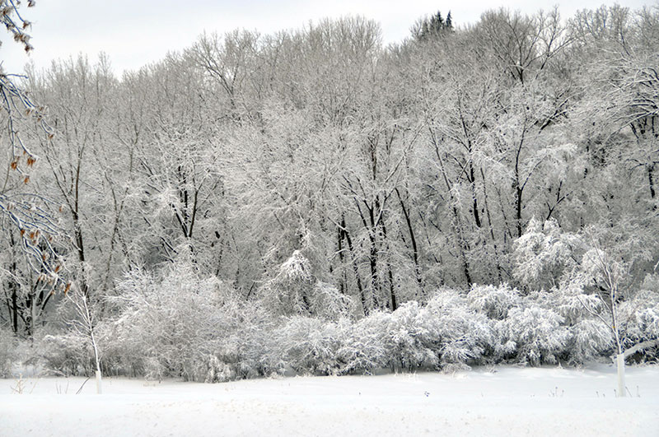

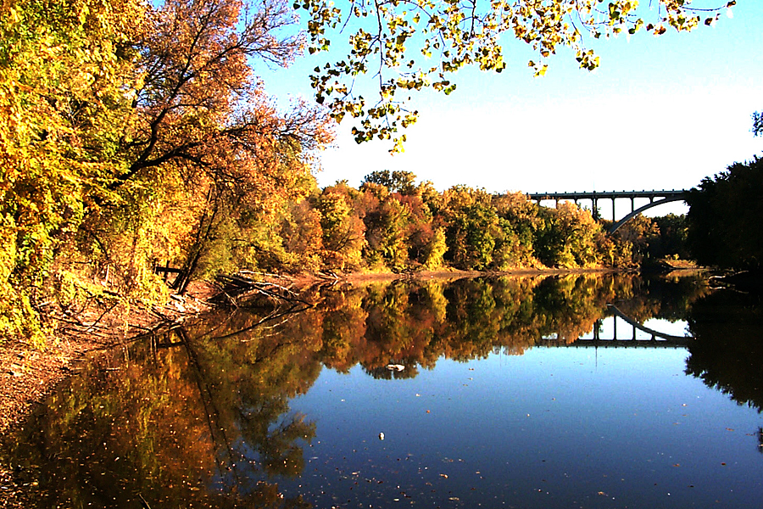

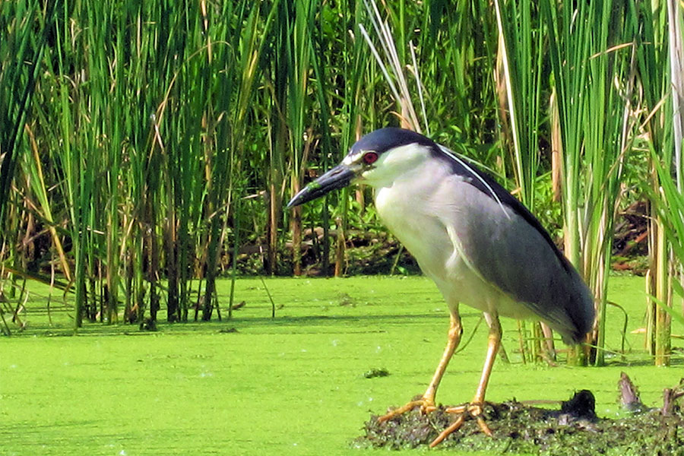



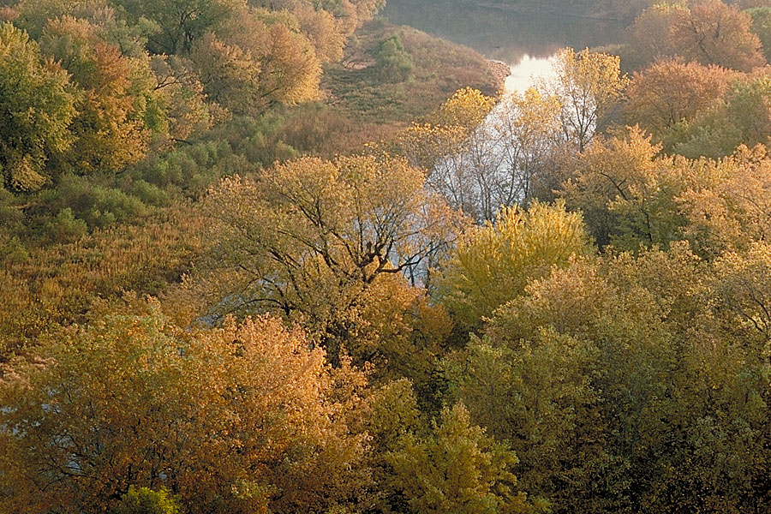

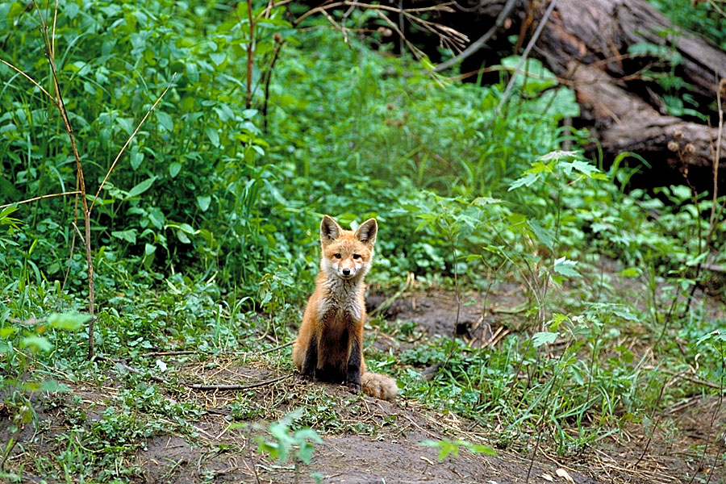

## Contact Information

### Address

101 Snelling Lake Road  
St. Paul, MN 55111

## Website

https://www.dnr.state.mn.us/state_parks/park.html?id=spk00154#homepage

# Forestville/Mystery Cave State Park

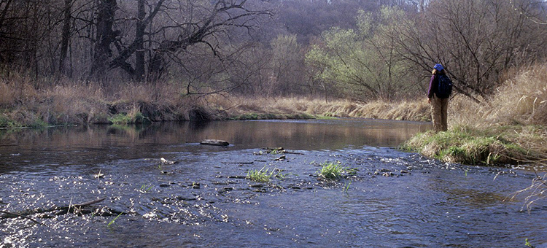

## Highlights

* Tours of Mystery Cave
* Historic Forestville Tours
* Trout Streams
* Camping
* Great Hiking/Horseback Trails
* Spring Flowers

## Geology

In the center of the park, along the South Branch of the Root River, is the townsite of Forestville. Founded in 1853, the village emerged as a rural trade center, typical of hundreds that emerged across southern Minnesota during the 1850s. Area farmers came to Forestville to trade their farm produce for goods and services. By 1858, Forestville numbered 100 inhabitants and had 20 buildings including two general stores, a grist mill, a brickyard, two hotels, a school, and mechanics of several trades. Forestville prospered until the first area railroad, the Southern Minnesota, bypassed the community in 1868. Village residents watched their town struggle to survive, while towns served by the railroad boomed with prosperity. By 1890, Thomas J. Meighen, son of one of the town's founders, owned the entire village. The 50 residents made their living on Mr. Meighen’s farm. In return for their work, his employees received housing, board and credit in his store. Mr. Meighen also maintained a post office, the school, a feed and a saw mill.

## History

The great variety of habitats supports remarkably different wildlife ranging from rare glacial snails to timber rattlesnakes. While a few rattlers live in the park, they are of very little threat if left alone. Please report sightings. Other wildlife of note include deer, raccoon, beaver, mink, opossum, woodchucks, four species of squirrels, red and grey fox. Coyote numbers have grown in recent years and can often can be heard at dusk. Several species of reptiles and amphibians are also present. At least 175 species of birds have been recorded in the park including several important neotropical migrants (scarlet tanager, oven bird, redstart) and a sizeable population of wild turkeys. Barred owls often wake campers with after dark calling and soaring turkey vultures delight summer visitors.

## Landscape

Two to five hundred million years ago material was deposited in the bottom of shallow seas which intermittently covered large portions of North America. As the deposits increased in thickness, the layers on the bottom were compressed to form limestone, shale and sandstone. Today in the park, these rocks are 1300 feet above the sea. They are an important factor in the development of the terrain which exists now.

## Park Information

Visit Forestville/Mystery Cave State Park to see natural wonders above and below ground. In the summer, beat the heat with a visit below ground. Explore the world of Mystery Cave with its stalactites, stalagmites, and underground pools. Park naturalists provide tours of the cave throughout the summer and on weekends in the spring and fall. The temperature stays at a constant 48 degrees Fahrenheit. Learn more about Mystery Cave Tours.

## Wildlife

Above ground, stop by Historic Forestville, a restored 1800s village operated by the Minnesota Historical Society (MHS). Fish three blue-ribbon trout streams for brown trout. Take in the soft pastels of wildflowers in spring or listen to ruffed grouse drumming and wild turkeys gobbling. Hike or bring your horse to ride the ridge tops and stream valleys. Observe interesting geologic features along the way including sinkholes and dramatic Big Spring. In the fall, don't miss the bold colors of the forest. Winter invites visitors to ski or snowmobile the Bluff Country.

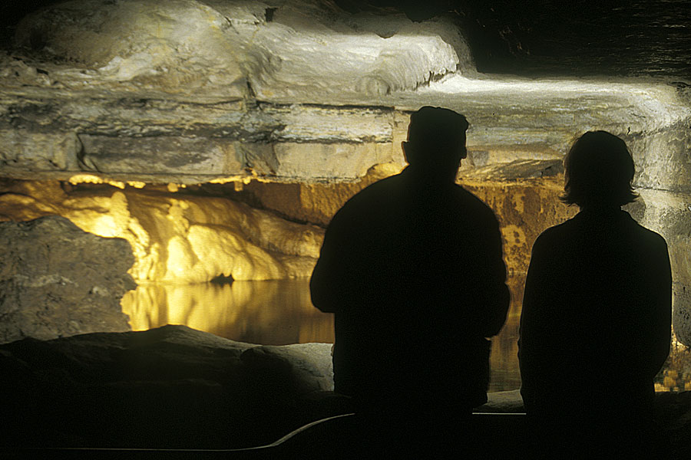

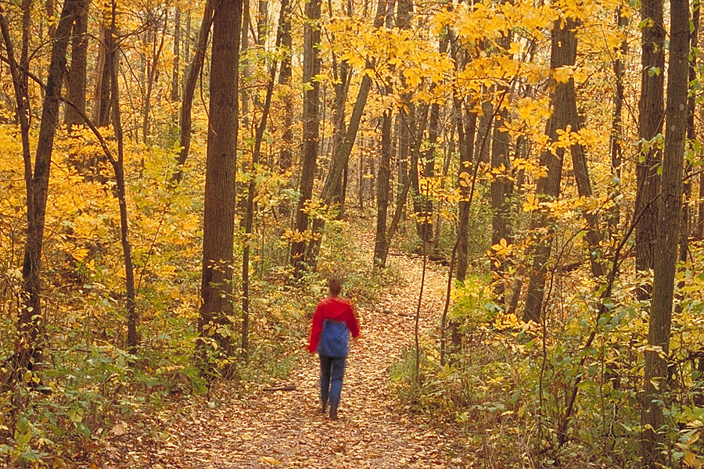

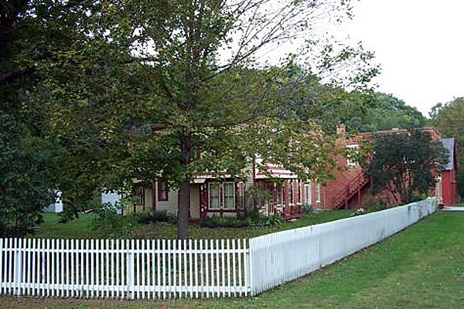

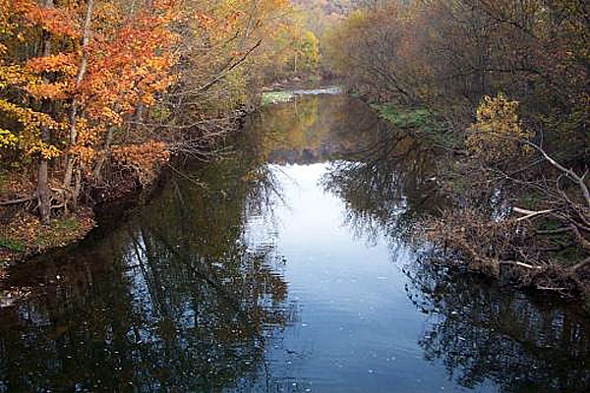

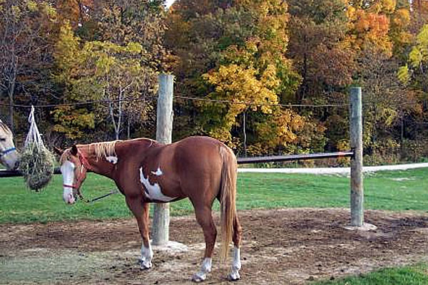

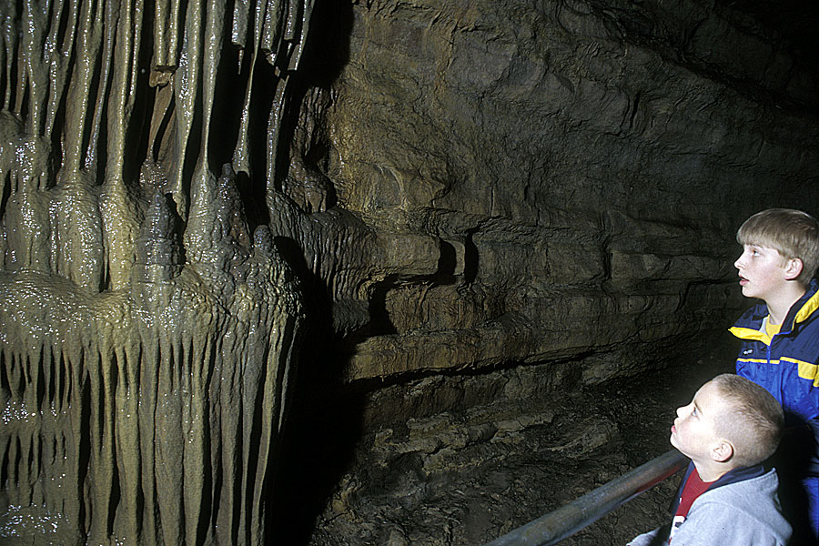

## Contact Information

### Address

21071 County 118  
Preston, MN 55965

## Website

https://www.dnr.state.mn.us/state_parks/park.html?id=spk00148#homepage

# Big Stone Lake State Park

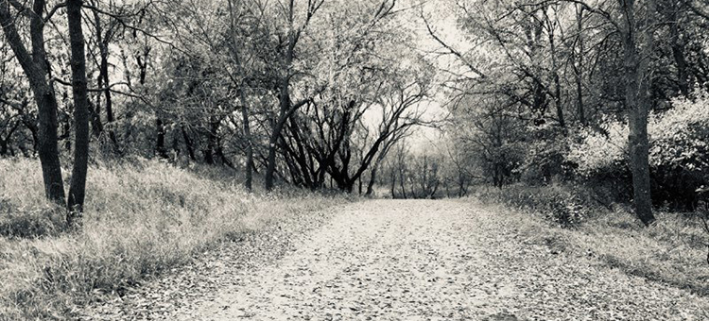

## Highlights

* Lakeside Campsites
* Fishing
* Bird Watching
* Native Prairie/Oak Savanna in Scientific and Natural Area
* Wildflowers Spring/Summer

## Geology

Long ago, this area was the south end of glacial Lake Agassiz. Torrents of water cut the valley when glacial river Warren drained Lake Agassiz. The area around Big Stone Lake State Park consists of granite and gneiss quarries. The top three inches of stone is exposed and contains the fossil remains of sharks' teeth.

## History

In 1923, State Auditor Ray Chase critiqued the state park system and thought there was a geographic imbalance in the system. In his proposal for additional parks, Chase urged that more state parks be established in southern Minnesota. The Ortonville area was targeted as a place with a need for a state park. It wasn't until 1961 that Big Stone Lake State Park was established at the urging of Ortonville business people who were concerned about lakeshore development. Working with U.W. (Judge) Hella, director of Parks and Recreation Division, legislation was drafted to establish Big Stone Lake as a state park.

## Landscape

Big Stone Lake State Park is part of the Minnesota River Country Landscape Region, a large area which extends almost 200 miles from Ortonville to Mankato. At one time, the landscape consisted of tall and mid-grass prairie, interspersed with marshes, lakes and streams. Today, extensive farming has replaced the prairie. Cottonwoods, ash, and silver maples can be found on the lake's shoreline. The Bonanza Scientific and Natural Area located within the park protects more than 80 acres of native oak savanna and glacial till prairie habitat. Bonanza also includes 50 acres of oak basswood forest and spring-fed ephemeral streams.

## Park Information

Big Stone Lake is 26 miles long and is located on the South Dakota-Minnesota border. The lake is the source of the Minnesota River and attracts anglers who catch walleye, northern pike, yellow perch and bluegills. The northern section of the park, called the Bonanza Area, provides a picnic area and boat launch for guests. The area also includes the Bonanza Education Center which provides a place to discover the past and ways to preserve it. The southern section of the park, called the Meadowbrook Area, contains a campground, swimming beach and hiking trails.

## Wildlife

Deer, raccoons, thirteen-lined ground squirrels, meadowlarks, sedge wrens, pheasants, bobolinks, wild turkeys, thrashers, and mourning doves are sighted in the park.

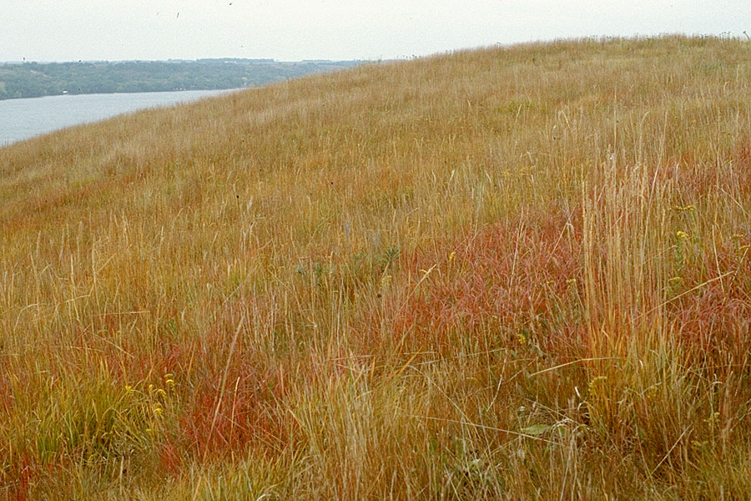

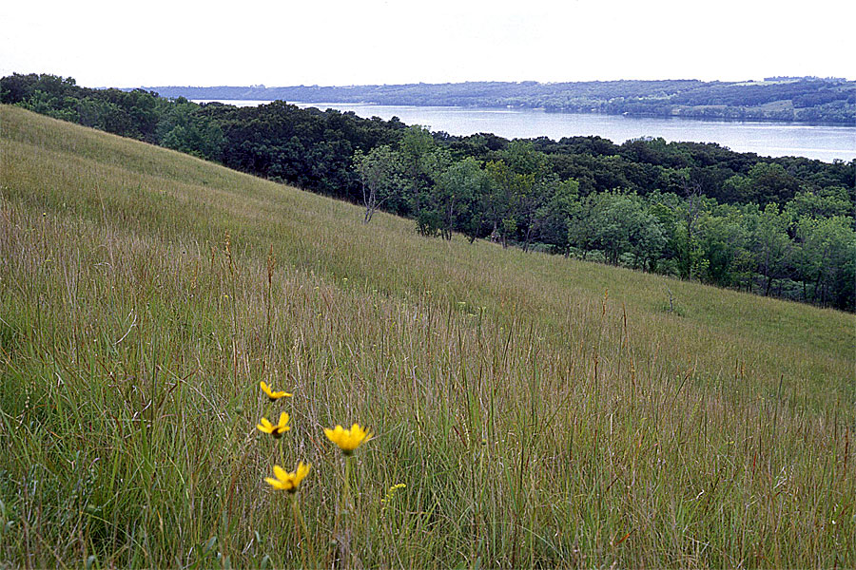

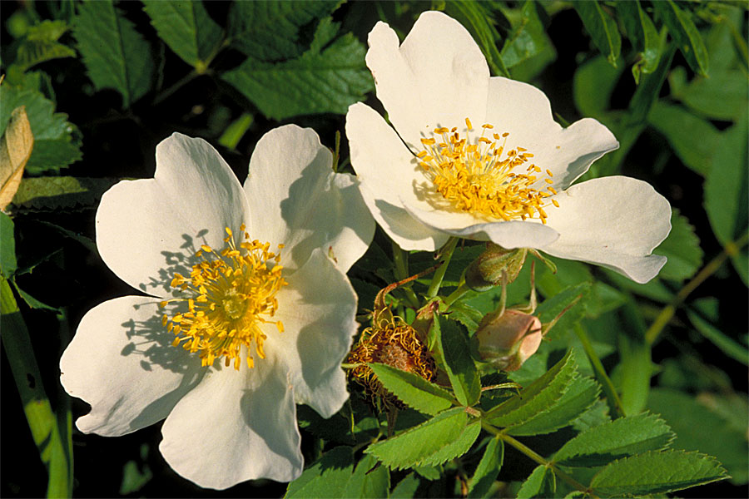

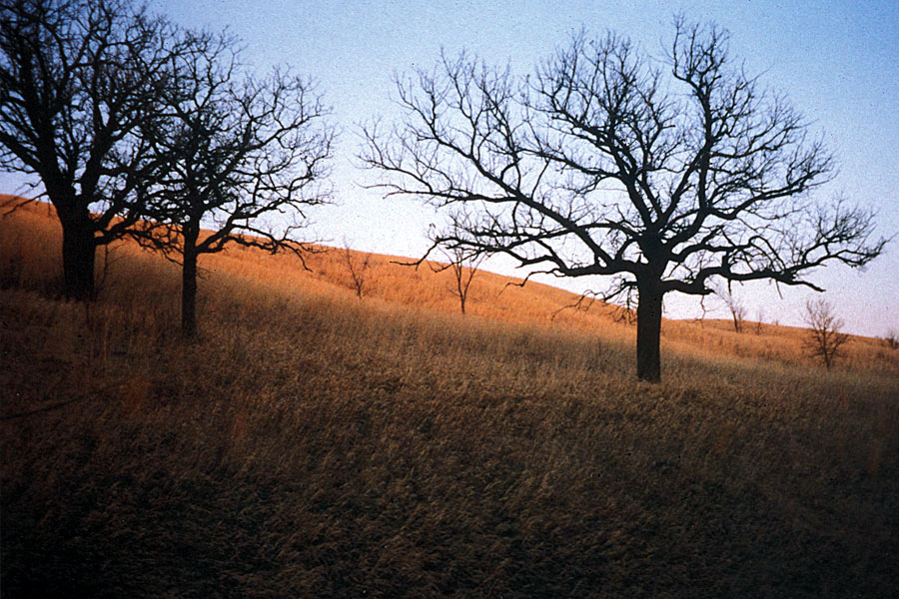

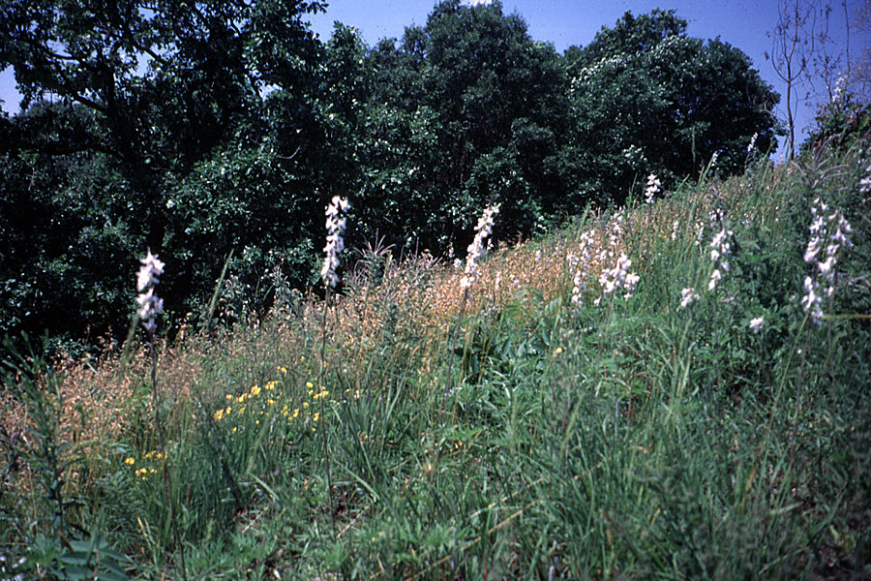

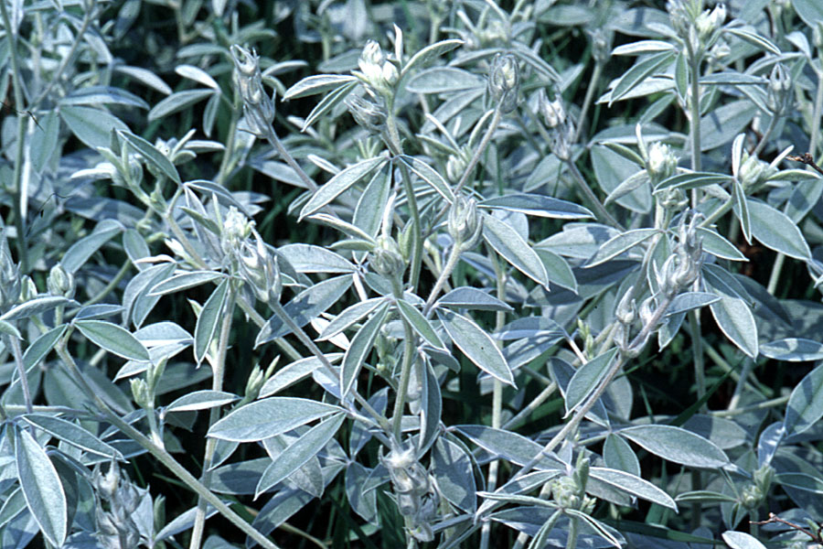

## Contact Information

### Address

35889 Meadowbrook State Park Road  
Ortonville, MN 56278

## Website

https://www.dnr.state.mn.us/state_parks/park.html?id=spk00115#homepage